Game Proposal

Title: I Want to Play My Game

Armaan Bandali

301322810

IAT 167

D104

**Overview**

“I Want to Play My Game” is a game about wanting to play games with your friends but having to do your chores first. The main character is about to play an online game with friends before being interrupted by his family to help around the house first: helping with each chore is itself a minigame. The 3 minigames are mowing the lawn while avoiding obstacles, throwing trash (like a basketball) into bins (like hoops), and a memory matching game to entertain your brother. To beat the level, you must complete your chores before your friends go offline. This game falls under the action and puzzle genres.

**Types of Fun**

The minigames allow the player to experience fun in the form of challenge and narrative. The challenge comes from trying to beat each minigame before time expires. The narrative fun comes from experiencing the story of you interacting with your family and the dialogue.

**Goals**

The overarching goal is to complete all 3 minigames within the time limit. For the mowing minigame, the goal is to move your character over all the unmowed grass to progress. For the trash throwing minigame, you must land all the trash bags into the bins to progress. For the memory matching minigame, you must find all the matching pairs of symbols to progress.

**Mechanics**

The player enters a cutscene composed of dialogue, then is able to use the mouse to select which minigame to play; after a minigame is complete, the player cannot select the respective minigame. In the mowing minigame, the player can move over the game area. In the trash throwing minigame, the player can use the mouse to aim his throw and click to throw the trash. In the memory matching game, the player can use the mouse to select a card to try to match its symbol with another card.

**Storyboard**

The storyboard shows primitive designs for all screens that will be in the game. The layout will generally stay the same, but design and details will change.

**Interaction Design**

The mouse will be used to click on the level-select, to set the power of the throw in the trash throwing minigame, to select options on the start and end screens, and select the card you want to match in the matching minigame. The mouse will also be used to navigate between options on the start and end screens, navigate through the level select, set the throw angle in the trash throwing minigame, and navigate between cards in the matching minigame. The arrow keys will be used to move the character in the mowing minigame.

The only part of the HUD will be the countdown timer before game over.

**Motivation Design**

The motivation for the player comes from trying to complete the minigames within the time limit and achieve the fastest time possible for each level.

**Narrative Design**

As previously mentioned, you are trying to play games with your friends online but must complete 3 chores (minigames) before your friends go offline. The chores are requested by each member of your fictitious family. The level select shows each minigame as a different area around the house. Dialogue throughout the game has your character complaining to himself and his family members.

**Difficulty Scaling**

The game will have 3 levels, which take place over days within the game. Each day has you wanting to play your game but having to complete the same set of chores again. The difficulty in the mowing game will be increased between levels by adding more obstacles that use up time when crashing into them. The difficulty in the trash throwing game will be increased by increasing the number of trash bags to throw and the throw distance. The difficulty in the matching game will be increased by increasing the number of cards to match.

**UML Diagram**

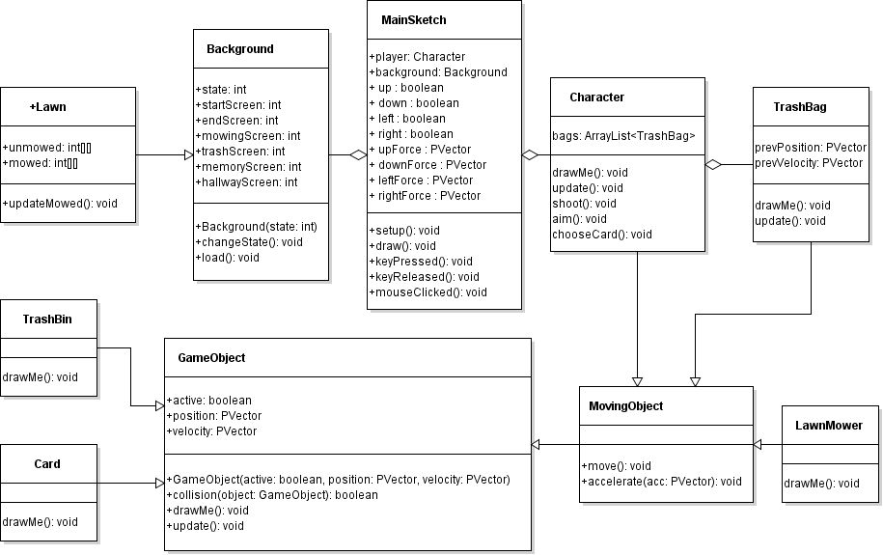

**Feature breakdown and timeline**

The first priority is to use placeholder objects to implement each minigame’s logic independently (by April 2). The second priority is to implement the transition screens and game states (by April 7). The third priority is to add the appropriate images and backgrounds (by April 12). The fourth priority is to add dialogue and narrative elements (by April 15).